TAB 1- Displays movie list with out pics

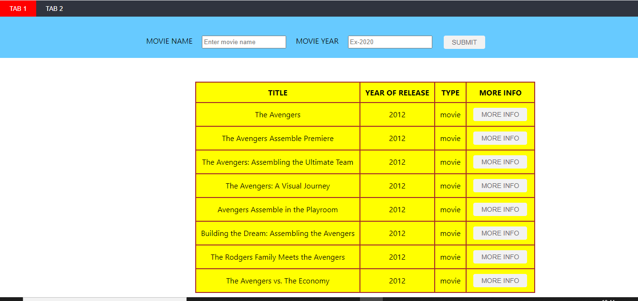

On clicking on more info display’s all the details of the movie with poster.

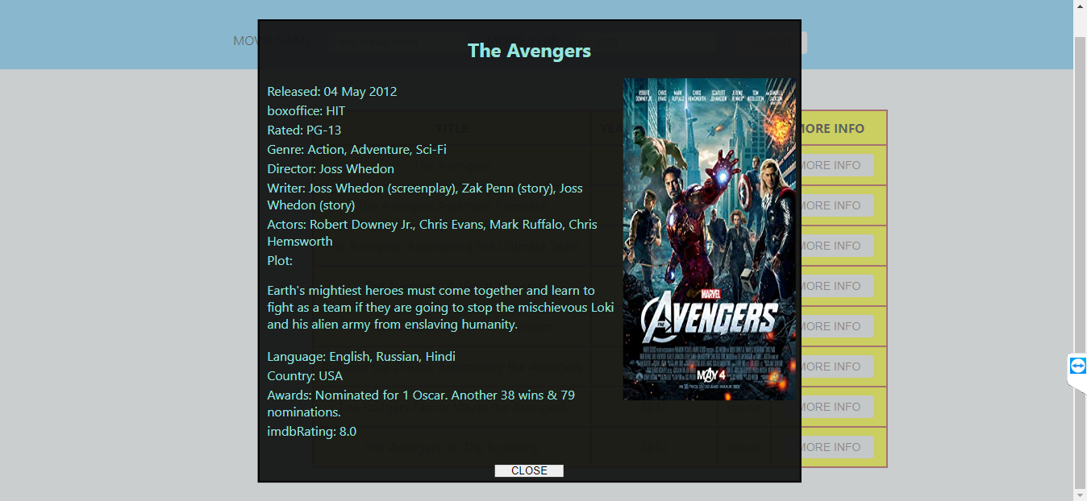

TAB 2 – Displays movie list with pic

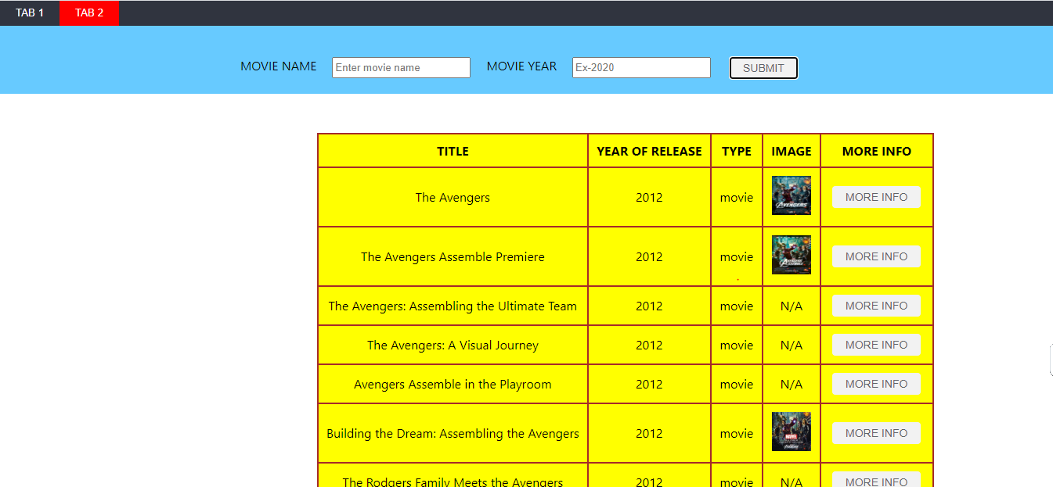

On clicking on more info display’s all the details of the movie with poster.

